TEXT TO PERFORMANCE ACTIVITIES
SESSION 2023-24

Name of the Department : English
Title of the Initiative: Certificate Course on Drama in Performance
Date: 16th February 2024 to 16th May 2024
Semester: IInd and IVth Semester
No. of Students participated: 30
A Brief Report: A certificate course on Drama in Performance was conducted by the Department of English focusing on the skills of acting, body movements, voice modulation, and costume designing. The students were provided with a brief knowledge on Indian classical drama and Indian literature whose roots can be traced back to the Rig Veda (1200-1500 BCE). Mr. Jyoti Narayan Nath an eminent Assamese actor and National School of Drama alumni along with Ms. Babi Baruah also an alumni of National School of Drama conducted the course. They handled both theory and practical classes for the course. Detailed classes on the play Mrcchakatika (The Little Clay Cart) were taken and a scene from the play was enacted on 16th March 2024 where the Principal along with the Vice Principal along with other dignitaries were present during the presentation of the scene.
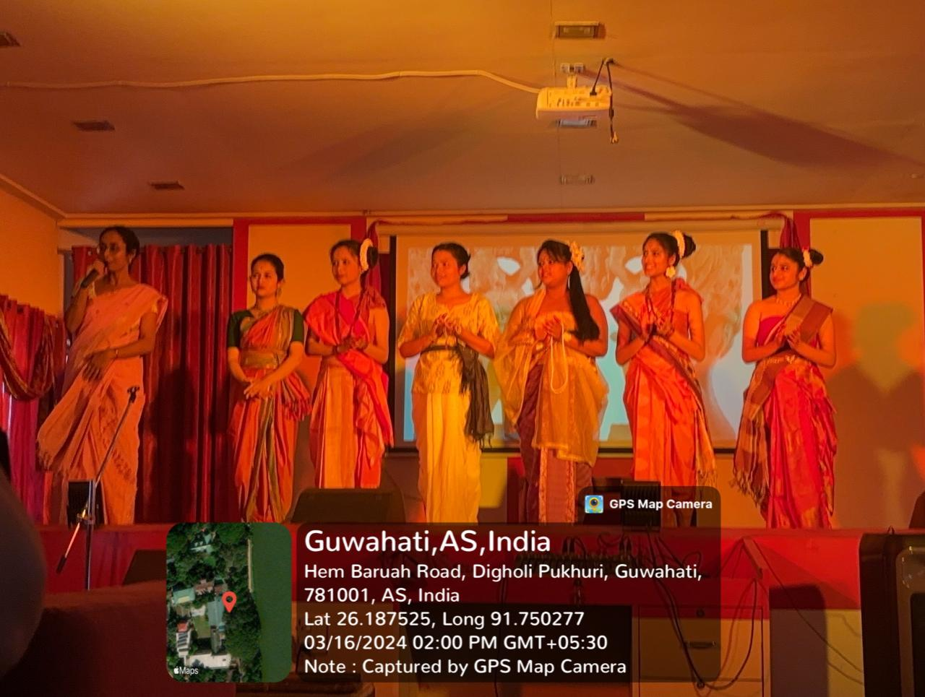

'Text to practice/performance' Initiatives
i. Name of the Department : English
ii. Title of the initiative: Performance of ‘She Stoops to Conquer’(Text prescribed in 4th sem Major)
iii. Date:12.3.24
iv. Semester: IV
v. No. of Students' who participated: 13
vi. A brief report on the theme of the activity with learning outcome:
The 4th semester students of the English Department presented a performance of the 18th century play ‘She Stoops to Conquer’ by Oliver Goldsmith at Damdama College as part of an extension activity under the MOU signed between HGC and Damdama College. The students drafted the script of the play adapting it to the cotemporary context and made it multilingual so that it reaches out to a greater audience. The students stood in a semi-circle and moved in and out of it to dramatize some of the important scenes. Two student actors acted as the commentators to the play.
Learning outcome: As the students had to draft their own script , they had to thoroughly read the whole text to comprehend it . That brought about a complete familiarity with the text. They also had to choose the most important scenes from each act to be performed and analyse their contribution to the progression of the plot. This helped them develop their analytical skills and understand the structure of the plot construction together with how humour has been generated in the text. The also had to identify the play as an exercise in anti-sentimental comedy and discern the techniques used by the writer to establish the play as one. The students of Damdama College also got an exposure to the performance and the whole exercise contributed towards a better understanding of the play for all the students present.
vii. Remarks (if any)
viii. Geotagged photos:

